Manila Water Company

technical specification - Enhancement
DID_M2C_166
Bill Print Email Functionality.

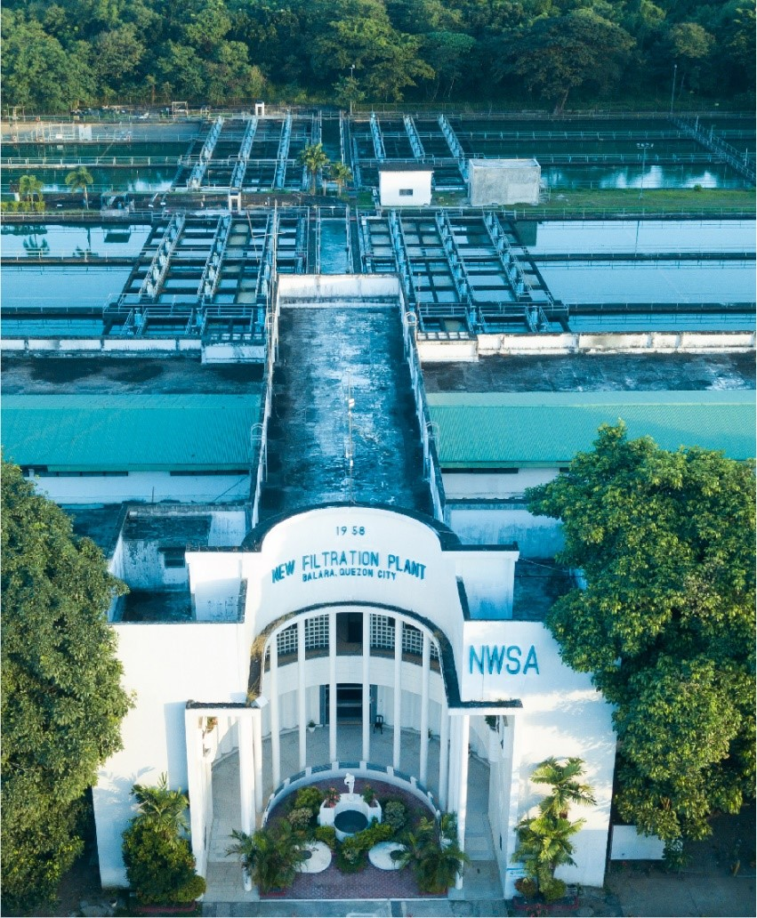
Contents
1 Document Organization 4
1.1 Document Log 4
1.2 Integration, Document Reference 4
2 Program Attributes 5
2.1 Authorization Requirements 6
2.1.1 Definition 6
2.1.2 Defined Fields 7
2.1.3 Procedure 7
2.2 Technical Flow Diagram 7
2.3 Processing Logic 7
2.4 Error handling 7
2.5 BRF Details 7
2.6 Fiori Extension 7
2.7 Cloud Extension 7
2.8 Custom DDIC Objects 8
2.9 Custom Business Object Details 8
2.10 Custom CDS Views Details 8
2.11 Custom Field details 8
2.12 Custom Logic/Enhancement Details 9
2.13 Custom Reusable Elements (Code-list, Library) 9
2.14 Form & Email Extensibility 9
2.15 Messages 10
2.16 Subroutines 10
3 Assumptions in Technical Design 10
4 Open Issues in Technical Design 10
5 Unit Test Results 10
6 Related Documentation 11

Document Organization
This section provides details about this document, previous version(s) of this document and the document(s) referred.

Document Log
Following table mentions the version changes and the processer(s):
Version | Status | Date | Version Created by (Name/E-Mail/Company) | Role | Comments
1.0 | Draft | March 19, 2025 | Sayyad Sarfraz Ali | Author

Integration, Document Reference

S. No. | Referred Document Name | Referred Document Version | Referred Document URL (Optional)
1 | Bill Print FS for R&B | V0.3 | To Be updated
2 | Bill Print FS for OSB | V0.3 | To Be updated

Program Attributes

Enhancement Object
Include | ZAB_M2C_166_BILL_email_top.  ZAB_M2C_166_BILL_email_e01.  ZAB_M2C_166_BILL_email_f01.
Message Class | ZMC_M2C_MD

Transaction Code | Z_EMAIL_INVOICE_PDF

Custom Tables | ZDT_M2C_ELOG

Authorization Requirements
N/A

Definition

Defined Fields

Procedure
1 Ensure Required Fields
- Either the date and invoice document must be present, or the date along with either the contract account number or MRU must be provided.
2 Check Invoice Print Status
- Verify whether the invoice has already been printed by retrieving data from the ERDK table based on the provided document number.
3 Fetch Required Details
- If the MRU is not provided:
  - Check whether billing data exists.
    - If billing data exists:
      - Retrieve the email address from the ADR6 table.
      - Fetch MRU details for each installation number from the EANLH table.
    - If billing data does not exist, display an error message.
- If the MRU is provided:
  - Check whether billing data exists.
    - If billing data exists:
      - Retrieve the email address from the ADR6 table.
      - Fetch the contract account number from the ERDK table.
      - Retrieve all associated MRUs.
    - If billing data does not exist, display an error message.
4 Validate Email Address
- Ensure the recipient’s email address is valid.
5 Prepare Email Content
- Create the email subject and message body.
- Attach the invoice PDF to the email.
- Add recipients to the email.
6 Send Email
- Initialize CL_BCS for email transmission.
- Log the success or failure of the email transmission in the ZDT_M2C_ELOG table.
7 Display ALV Report
- Present all logs in the final ALV report.

Technical Flow Diagram
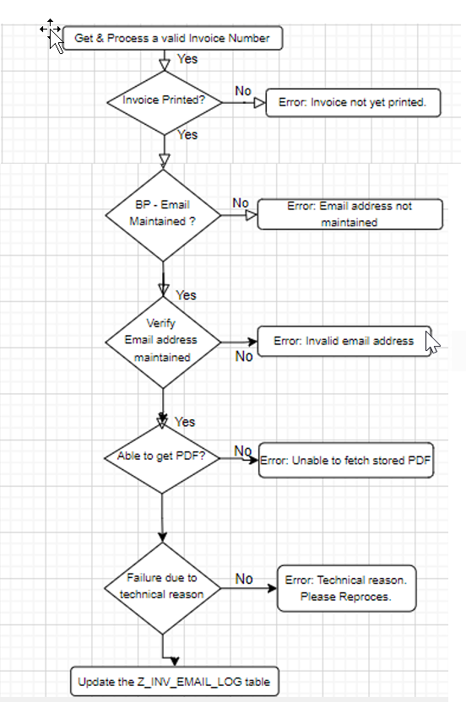

Processing Logic
1. Input
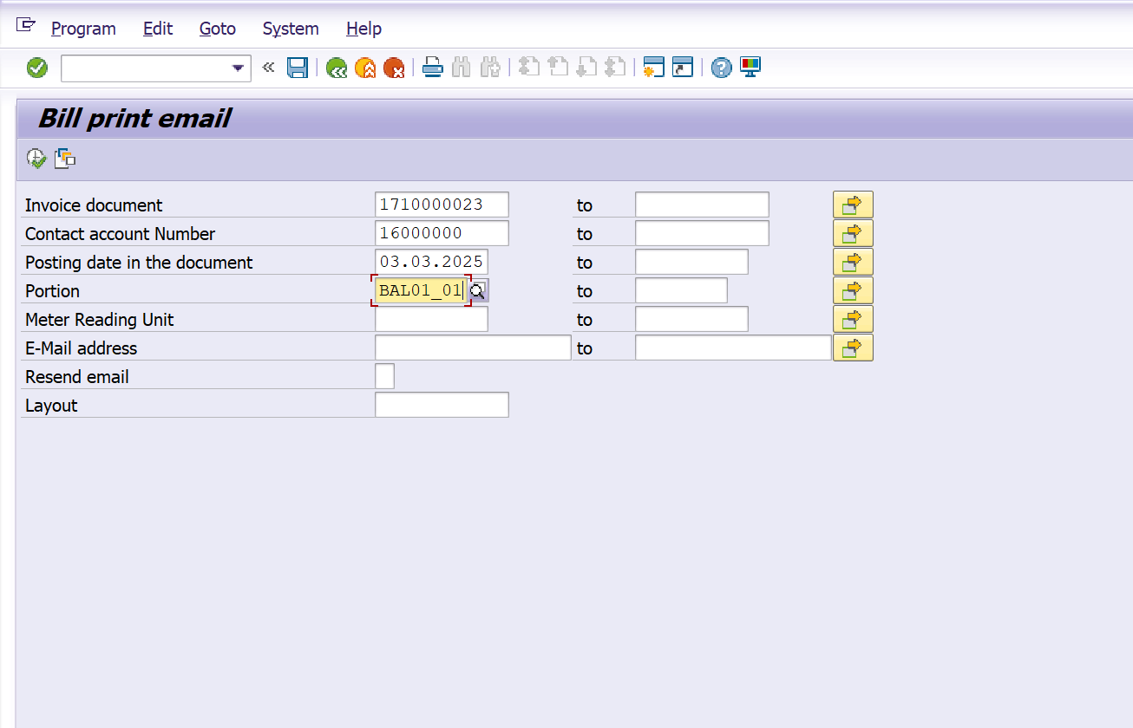

2. Output
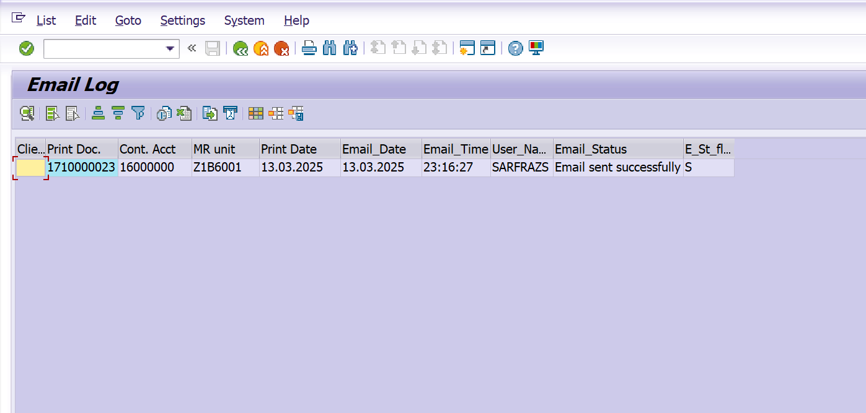

3. Email

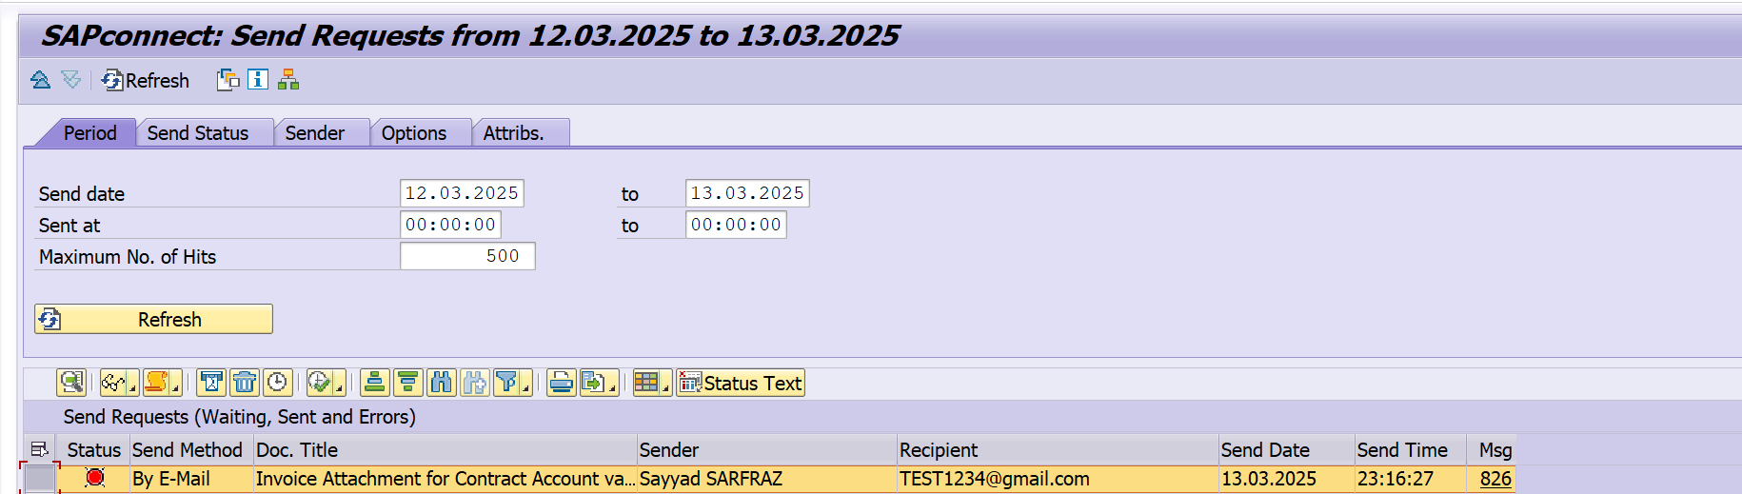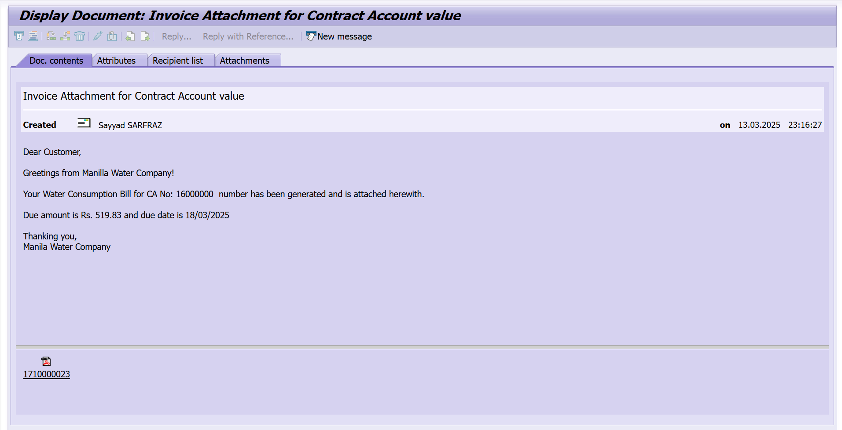

4. Log table - ZDT_M2C_ELOG
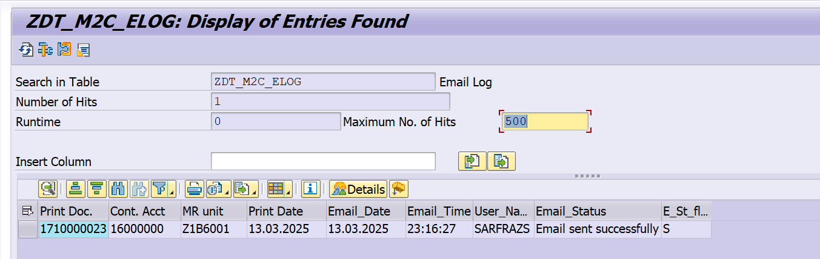

Error handling
N/A

BRF Details
N/A

Fiori Extension
N/A

Cloud Extension
N/A

Custom DDIC Objects
Database Table : ZDT_M2C_ELOG

Custom Business Object Details
N/A

Custom CDS Views Details
N/A

Custom Field details

Custom Logic/Enhancement Details

Enhancement Name
Logic

Custom Reusable Elements (Code-list, Library)

Custom Code list
Used in

Custom Library Name

Form & Email Extensibility

Form Templates
Email Templates
Data Source Details

Messages
Message Class | Message ID | Message Text

Subroutines
Name | Description

Assumptions in Technical Design

Open Issues in Technical Design

Unit Test Results

Scenario # | Input Selection Criteria | Expected Result | Actual Test Pass/Fail
 |  |  | Choose an item.
 |  |  | Choose an item.
 |  |  | Choose an item.

Related Documentation

Template Version
Version | Status | Date | Version Created by (Name/E-Mail/Company) | Role | Comments
1.0 | Final | February 11, 2019 | Abhishek Nayak | Author
1.1 | Final | March 15, 2022 | Abhishek Nayak | Author | Updated to include In-App Extension artifacts like Custom logic, Custom Fields, Custom BO, Custom CDS Views, Custom Code list, Libraries, Form & Email Extensibility.

